<Gravity 2048!!>

Made by 22-124 최지후

This is a game inspired by the famous game <2048>.

If you type your student number in the first screen, you will then see the game screen.

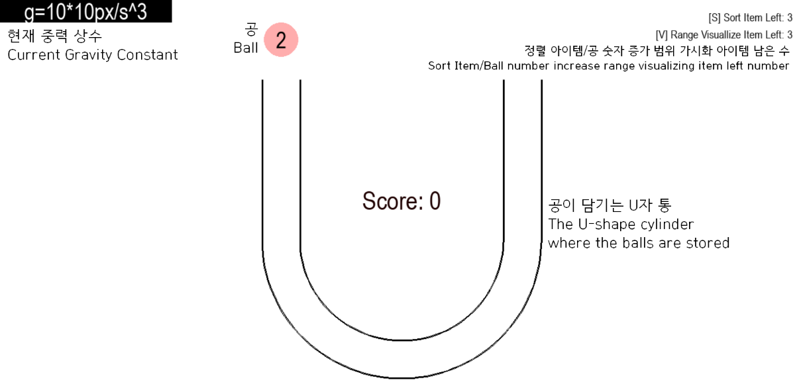

At every turn, the ball is generated randomly at the left/right entrance of the cylinder, and the number on the ball is determined randomly based on the minimum value of the current set of balls in the cylinder. You can determine where to drop the ball by clicking it and dragging it to the adjust height.

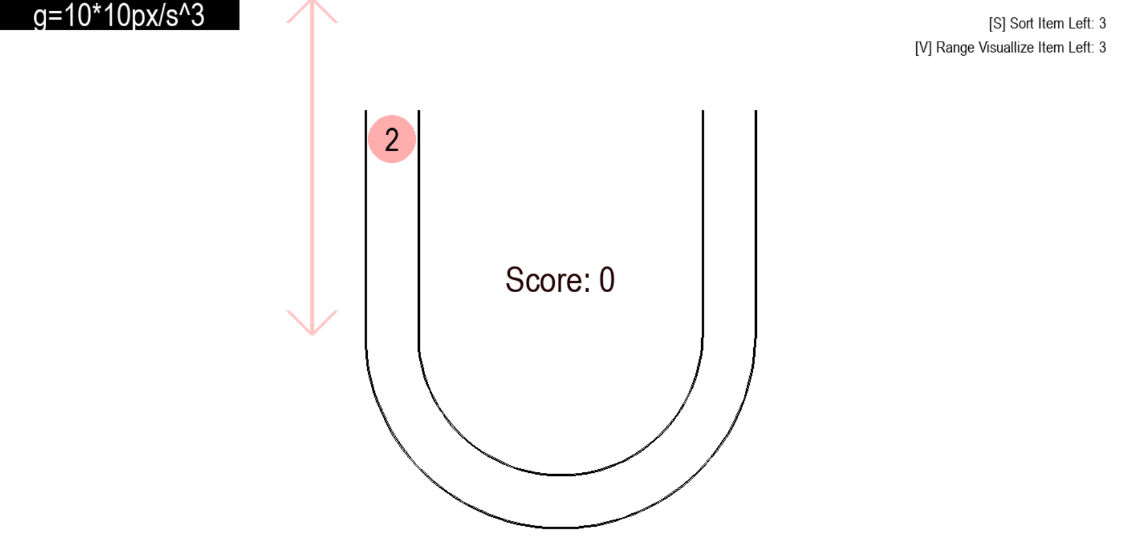

If you release the mouse, the ball drops. The important thing is that **the number on the ball increases as the ball drops**. After every 1 second after you released the ball, the ball’s number is doubled. Also, the ball is accelerated as it drops. The formula of the height the ball dropped t seconds you released it is like this. Sorry for not following the right physics formula :( (Let’s just think it as a parallel universe)

$$∆y=-\frac{1}{2}gt^{3} (g:gravity constant, unit:px)$$

As the rule of 2048, when the balls with the same numbers collide, they are merged. Then, the score is increased as the number of the number of the resulting ball. The game will end if a ball’s height is higher than the entrance of the cylinder. So, your goal is to merge as many balls as you can while adjusting the dropping height.

However, to make your play more easy, I added 2 Items.

1. Sort Item: Use it by pressing the s key. It sorts the balls in the cylinder to make the biggest number ball in the lowest position and the small balls to be at the highest place. It also merges the balls automatically if some balls are adjacent and have the same numbers. Also, it makes you easy to make a chain of merges in your afterward plays.
2. Ball-Number-Increasing-Range Visualize Item: Use it by pressing the v key. It shows you the amount of the ball’s number’s final increase at each height of the potential drop zone. The range is visualized using colors: red, orange, yellow, green, blue, dark blue, purple, and brown. The red means the number doesn’t increase, and orange means it is doubled, and yellow means it is doubled 2 times, … and on. Because the game mechanism, this range might not be exact, but it will definitely help you to find the adjust height to drop it.

Each item can be used to 3 times.

I had reached 29000 points maximum. I think you can reach 100000 points during the SAC! Good luck!